**MarketManager**

User Manual

COMP208 Group 21

James Herbert, Razmig Couligian, Jonathan Ash, Matthew Fisher, Simon Hutchinson and Owen Miller

|  |  |  |
| --- | --- | --- |
| Preface | **Welcome to Market Manager**  About MarketManager  About the MarketManager Documentation  The MarketManager Website Interface  Additional Resources and Help | 3  3 3 4 5 |
| Chapter 1 | **The Home Page** Getting Started | 6  6 |
| Chapter 2 | **The My Account Page**  Creating a MarketManager Account  Signing into an existing Market Manager Account  Resetting an account’s password | 7  7  8  8 |
| Chapter 3 | **Viewing Asset Data**  The Dashboard  Saving asset tickers  Viewing asset charts | 9  9  10  10 |
| Chapter 4 | **The News Page** Viewing the Latest News | 12  12 |
| Chapter 5 | **Technical Overview of Technologies used in MarketManager** Frontend Development (React JavaScript)  Backend Development (Java Spring Boot)  MySQL Database  Running MarketManager locally on your machine | 13  15  15 16  17 |
| Chapter 6 | **Glossary** | 20 |

Contents

Welcome to Market Manager  
MarketManager is an easy-to-use website, that offers a straightforward way to view the financial data for publicly traded companies on the stock market.

The preface covers the following:

* About MarketManager (p. 3)
* About the MarketManager Documentation (p. 3)
* The MarketManager Interface (p. 4)
* Additional Resources and Help (p. 5)

About MarketManager  
MarketManager is a Progressive Web Application (PWA) used for tracking financial assets on a single website. Users can create and sign in using the MarketManager accounts system to ‘follow’ (save) their assets into the dashboard, where the assets’ financial data can be viewed in a graph for tracking the changes in the assets’ prices. Assets are saved into the dashboard using the company ticker which is a short identifier for recognising companies on the stock market.

About the MarketManager Documentation  
MarketManager comes with a manual that is designed to be used alongside the web application

* *MarketManager User Manual*: This is a comprehensive document that describes the interface, menus and commands for the MarketManager System. It has several step-by-step instructions for using the MarketManager System written for users of all levels of technical and financial experience. This manual is available as a PDF file.

The MarketManager Interface

|  |  |
| --- | --- |
|  |  |
|  |  |
|  |  |
|  |  |
|  |  |
|  |  |
|  |  |
|  |  |

[screenshot]

[screenshot]

[screenshot]

[screenshot]

Additional Resources and Help  
Along with the documentation that comes with MarketManager, there are other resources that come with MarketManager. This includes our presentation from *MarketManager Presentation* where more specific information and statistics can be found.

For help or specific questions with using MarketManager, please email:

The Home Page  
The Home Page is the main web page for MarketManager. This is the main page for viewing the time series charts of the saved companies. Here you can add and remove the tickers for companies to watch. Their financial data for Today, the past five days (5D) and the past month (1M) can all be viewed.

This chapter covers the following:

* Getting Started with MarketManager (p. 6)

Getting Started with MarketManager  
To start following a company’s price changes with the MarketManager system, press on the Get Started button to create an account.

[screenshot]

The My Account Page  
The My Account Page is used to manage your MarketManager account. Here you can sign in with a created account or sign up to create a free MarketManager account. When signed in, you can view your saved account details, view your saved companies or delete your account.

This chapter covers the following:

* Creating a MarketManager Account (p. 7)
* Signing into an existing Market Manager Account (p. 8)
* Resetting an account’s password (p. 8)

Creating an MarketManager Account  
To create a MarketManager account, press on the MyAccount option in the navigation bar. This should display the Sign In page.

[screenshot]

[screenshot]

To Sign up, press on the Don't have an account? Sign up! link. This will redirect you to the Create An Account page.

[screenshot]

Enter in the details that you would like to use to access your MarketManager account. Please ensure that your password has at least six characters. Then press on the Sign Up button.

[screenshot]

When your account has been created, you should see a popup that says User registered successfully!

[screenshot]

Signing into an existing MarketManager Account  
To sign into an existing MarketManager account, press on the MyAccount option in the navigation bar. This should display the Sign In page.

[screenshot]

Enter your details used to create your account in the Email and Password fields and then press on the Sign In button.

[screenshot]

This will then redirect you to the MarketManager Dashboard where you can view the company’s time series graphs.

[screenshot]

Resetting an account’s password  
If you have forgotten your account’s password, you can reset it by firstly pressing on the MyAccount option in the navigation bar. This should display the Sign In page. On the left of the Sign In button, there is an option for Forgotten your Password?

[screenshot]

Pressing on the Forgotten your Password? option will redirect you to the Forgotten Password page.

[screenshot]

Please enter your email address in the Email field and then press the Submit button and check your inbox (and spam) for the Reset Password Email and follow the steps.

[screenshot]

Please note that this feature is not available yet and it will be coming in a future release.

Viewing Asset Data  
Financial data for an asset can be viewed on the Dashboard, after signing in. Here you can see the time series and prices for companies specified by their ticker.

This chapter covers the following:

* The Dashboard (p. 9)
* Saving asset tickers (p. 10)
* Viewing asset charts (p. 10)

The Dashboard  
After signing in, you are redirected to the Dashboard page, where the time series and prices for companies can be seen.

[screenshot]

There are options for seeing the price changes for Today, five days in the past (5D) and one month into the past (1M) for a specific stock.

[screenshot]

Pressing on the Today option, shows the changes in price for the past 24 hours

[screenshot]

Pressing on the 5D option, shows the changes in price for the past 5 days

[screenshot]

Pressing on the 1M option, shows the changes in price for the past 30 days

[screenshot]

Saving Asset Tickers  
New assets can be added by navigating to the Dashboard page, after signing into your MarketManager account, and pressing on the + (add) icon in the button right of the screen.

[screenshot]

Pressing on the + icon, will display the Add a new asset page, where new assets price graphs can be followed.

[screenshot]

In the drop-down menu, you have the option to select a US stock or a currency exchange rate (Forex).

[screenshot]

##### In the What asset would you like to track field, enter the ticker symbol for the company that you would like to watch. The ticker for the company can be obtained by searching in a search engine for [Company_Name ticker].

##### For stocks, the ticker must be a symbol (i.e., several characters). For example, AAPL for Apple or IBM for IBM.

##### For Forex, the format is currency/currency. For example, EUR/USD for comparing Euro with US Dollar.

Once you have entered the desired company in the fields in the Add a new Asset page, press on the Add button which will update your Dashboard with the new asset data.

[screenshot]

Viewing Asset Charts  
Asset charts can be viewed by navigating to the Dashboard page after signing into a MarketManager page. The charts show the name of the asset in the top left, the prices along the y axis and the time in the x axis.

[screenshot]

The charts can be zoomed into, to view further price changes every 10 seconds. This can be done by holding left click with the mouse and highlighting the area that you would like to see further data on.

[screenshot]

In the top right of each chart, there is several icons for managing the functionality and type of visibility of the graph. The plus and minus icons can be pressed to manually adjust the levels of zoom. This might be used if a user has difficulty using the mouse or is on a mobile device.



The chart can be panned with the hand icon.

The home icon is for returning the chart to its default state.

The options icon is for downloading the chart for that particular time series window.

The News Page  
The News Page is used for seeing the latest news on the stock market. This could give an insight of companies that are performing well or performing poorly. This is designed to give the user a better background on the inner workings of the stock market and is not financial advice.

[screenshot]

This chapter includes:

* Viewing the Latest News (p. 12)

Viewing the Latest News  
The latest news about the stock market can be viewed by pressing on the News option in the navigation bar. This will redirect you to the Latest News about the Stock Market page. In this page, news based on companies in the stock market is shown and updated.

[screenshot]

More information about the news can be found out by pressing on the underlined titles which when hovered over with the mouse will turn blue. When one of these titles have been pressed, another tab will open in your web browser, which will contain the website and more information about the specific news.

[screenshot]

Technical Overview of Technologies used in MarketManager

There has been a range of technologies used in the creation and deployment of MarketManager. The development of MarketManager was split into two halves, the frontend and backend, which were based on two different technologies. For persistent storage for the accounts system, a MySQL database was used.

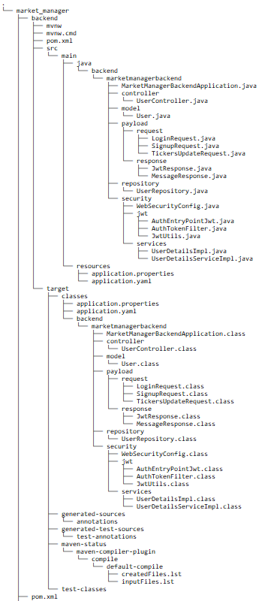The project was configured with the file structure seen below, which was used to speed up development time

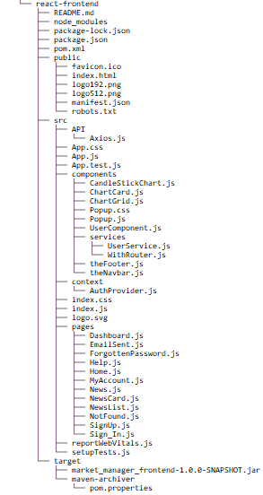

This chapter includes:

* Frontend Development (React JavaScript) (p. 15)
* Backend Development (Spring Boot Java (p. 15)
* MySQL Database (p. 16)
* How to run MarketManager locally (p. 17)

Frontend Development (React JavaScript)  
The development of the frontend was carried out using React JavaScript which is an open-source JavaScript library for building user interfaces. The frontend is responsible for the layout and the visible design of the website for MarketManager, and every design choice was made to make the website easy and straight forward to use. All code was written in the Visual Studio Code IDE.

Several other packages and API (Application Programming Interfaces) were used in the frontend. These include:

Java Packages:

* NPM (Node Package Manager) – For managing and install packages for JavaScript.
* React Scripts, React Dom, React Bootstrap, React Unicons – For installing and running code in the React Library
* Axios – This is HTTP client for connecting React and Spring boot.
* React Apexcharts – This is a library for displaying charts.

APIs:

* NewscatcherAPI – For displaying stock market news.

Backend Development (Java Spring Boot)  
The development of the backend was carried out using Java Spring Boot. Spring Boot is a Java framework used for making applications that run on the Java Virtual Machine (JVM). The backend is responsible for managing the account system for MarketManager and storing and retrieving that data from the MySQL database, to send or receive data from the frontend. This code was all written in Java, but the Spring boot dependencies were written in Maven, which is a build tool. Maven is used to build the Java code and allow calls to the libraries in the dependencies from Spring Boot. All Java code was also written in the Visual Studio Code IDE.

To test if the backend was able to handle data before connecting it to the frontend, a piece of software called Postman was used. Postman is an API testing tool that the team used to test the backend which is called from the frontend using an API.

MySQL Database  
For persistently storing account data, a MySQL database was used. This is because MySQL integrates easily with Spring Boot and only the MySQL dependency was required in the Spring Boot code.

Running MarketManager locally on your machine  
To run MarketManager on your machine several software tools are required. These steps assume that you are using a Debian based Linux distribution (such as Ubuntu), but they will be possible to use on other distributions, on Windows and MacOS with a little extra work.

Firstly, install the required tools:

Maven

sudo apt install maven

(For Windows, please ensure that Maven is set as an environment variable)

Node Package Manager (NPM)

sudo apt install npm

Git

sudo apt install git

Clone the project (this can be skipped if you already have the project files):

git clone [git@github.com:jash2002/MarketManager.git](mailto:git@github.com:jash2002/MarketManager.git)

Move into the react-frontend directory

cd MarketManager/market_manager/react-frontend

Then type

npm install --save react-bootstrap react-apexcharts @iconscout/react-unicons react-scripts

npm install --save vue-apexcharts apexcharts

This installs all the packages for the frontend

To start the frontend, type:

npm start

This should open a window connected to localhost:3000 with the MarketManager frontend

If it is successful, the terminal should look something like this:

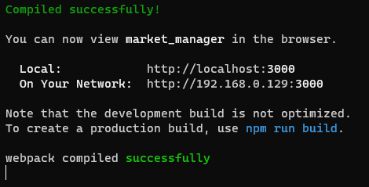

To start the backend, open another terminal window (leave the frontend terminal open) and navigate into the backend directory:

cd MarketManager/market_manager/backend

To start the backend, type:

mvn clean install

mvn spring-boot:run

When the backend has been started, this should (or something similar) appear in the terminal:

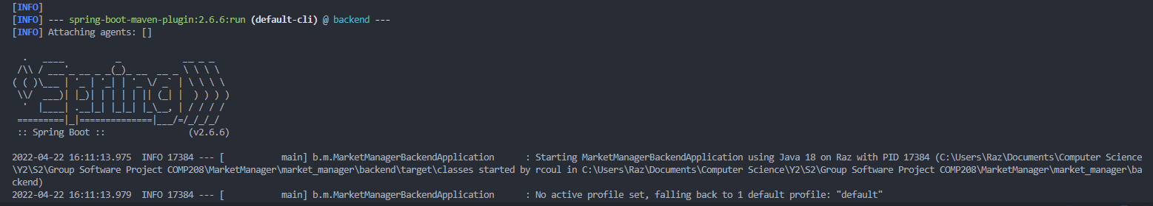

To test MarketManager, open your browser and navigate to the page opened by npm at the localhost URL. MarketManager is now running on your machine.

Glossary

|  |  |
| --- | --- |
| Term | Definition |
| API (Application Programming Interface) | Is a tool that allows certain types of software to be used externally. |
| Asset | Is a resource of economic value such as a stock, cryptocurrency or forex. |
| Backend | It is used to process the functionality of software that the user does not have access to. |
| Forex | It is a marketplace where currencies are traded. |
| Frontend | It is used to display the user interface that the user interacts with to use the software. |
| Integrated Development Environment (IDE) | It is an application used to develop software. |
| Java Spring Boot (Spring Framework) | It is an open-source framework that is used to develop micro services for software. |
| MarketManager | MarketManager is a Progressive Web Application (PWA) used for tracking financial assets on a single website. |
| Maven | It is a project management tool used to build software. |
| MySQL | It is an open-source relational database management system for storing data in SQL. |
| Node Package Manager (NPM) | It is a package manager for the JavaScript runtime environment for Node.js |
| Postman | It is an API development tool which helps build and test APIs. |
| React JavaScript | It is an open-source frontend JavaScript library for developing user interfaces. |
| Share | It is a unit of equity ownership in a company. |
| Stock (Equity) | It is a security that represents a slice (portion) of a company. |
| Stock Market | It is a place where shares of publicly traded companies are traded. |
| Ticker (Symbol) | It is a string of characters which represent publicly traded securities on an exchange. |
| Time Series Chart | It is a data set that tracks some data (an asset) over time. |
| Visual Studio Code | Is a commonly used IDE for developing code. |